

**UNIVERSITY OF PETROLEUM & ENERGY STUDIES**

**Dehradun**

**CONTINOUS INTEGRATION**

**AND**

**CONTINOUS DELIVERY**

**Containerization Lab**

**Name: Shivani Tyagi**

**Course: B. TECH CSE DevOps (2018-22)**

**Roll no.: R171218097**

**Sapid: 500067253**

**Experiment-11**

**Step-1:** Download and Install Virtual Box(5.2.44) as well as Vagrant(2.2.10)

* **Virtual box <https://www.virtualbox.org/wiki/Download_Old_Builds_5_2>**
* **Vagrant**

**<https://www.vagrantup.com/>**

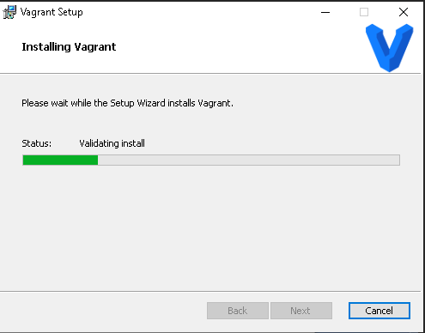

**Step-2:** After installing vagrant check the version and make a folder to initialize vagrantfile.

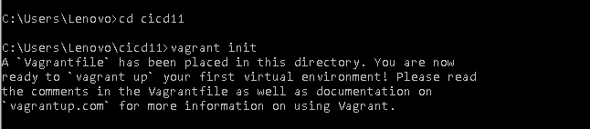

**Step-3:** Add **config.vm.box = "ubuntu/xenial64" to** vagrantfile

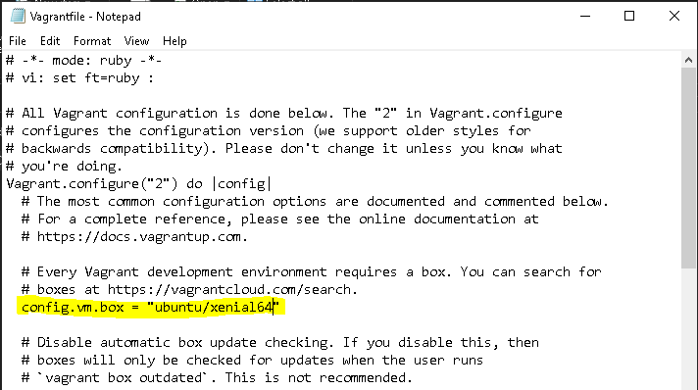

**Step-4:** Run **vagrant up** command

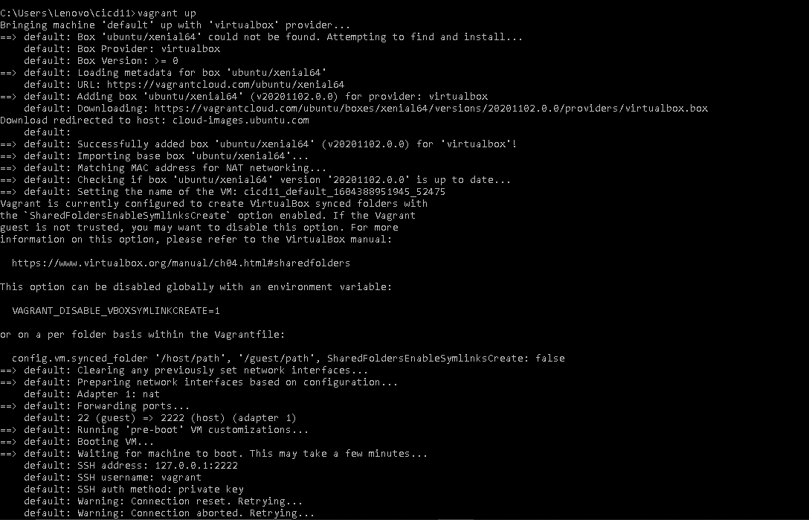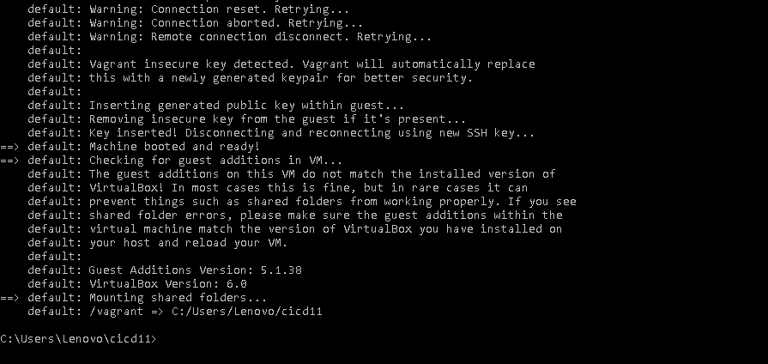

**Step-5:** Run **vagrant ssh** command to enter the virtual machine.

